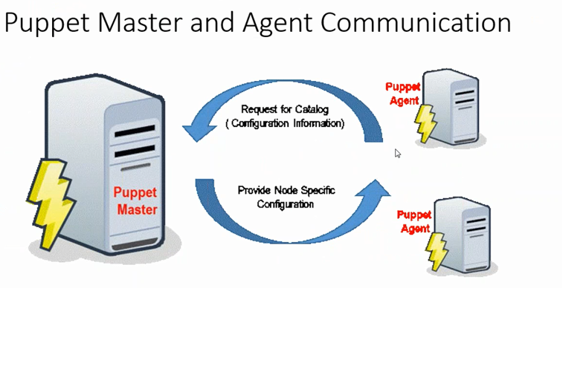

Runs under master-slave architecture

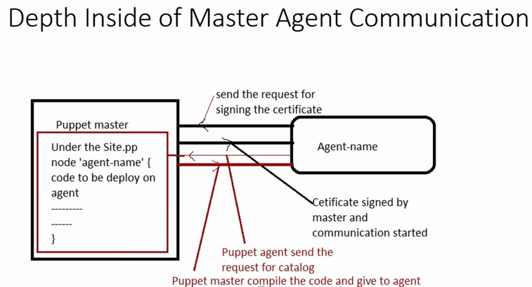

Puppet needs a certificate signing for client machine configuration because of it’s master slave configuration.

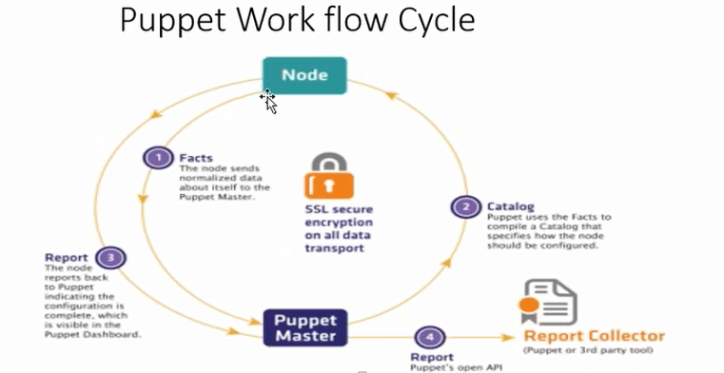

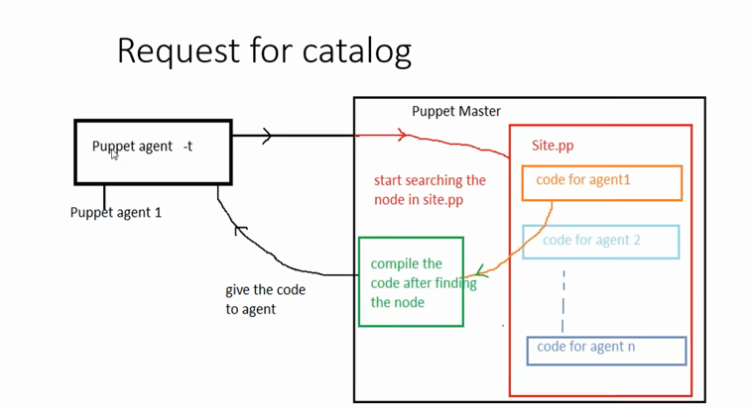

Nodes have to send facts using Facter to Master server and then Master Analyse facts and send suitable Catalog to that node, After configuring Node,it sends report back to Puppet Master (its optional feature)

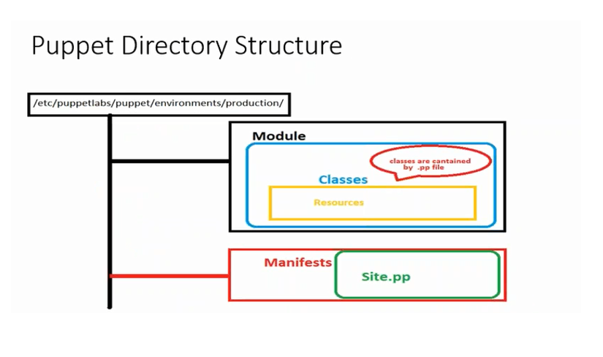

Puppet is configured with Puppet DSL only used for puppet. For that it is dependent on system admin. So you have to be a programmer to manage the configuration.For example any basic module development structure

We need to Ensure following 3 steps :

**1)** **Package management**

Ex: Node ‘xyz’{

Package “tomcat” {

Ensure=> install

**2)** **Configuration management**

Ex:file {“/usr/local/bin/jbossdeploy”:

ensure => present,

mode => 0755,

owner => ‘root’,

group => ‘root’

**3)** **Service management**

Ex:file {‘/usr/local/bin/jbosstop.sh’:

ensure => present,

mode => 0755,

content => template(‘jbossdep/jbossstop.sh.erb’),

} ->

exec {‘stop jboss’:

command => ‘/usr/local/bin/jbosstop.sh’,

path => [‘/usr/local/bin’]

}

}

**Puppet Hiera :**

Apart from this, there is advance option in Puppet, which is Puppet Hiera

its is a key value lookup tool which holds all the data that has to be dynamically placed in a module.

Using Puppet Hiera,we can store usernames, passwords, server details like DNS,LDAP server details etc. Moreover, we can encrypt the data in hiera for security.

Hiera resides in the puppet server for global access unless the client is operating in masterless setup. In that case, it resides in the client itself.

Hiera’s hierarchical look ups follow a “**defaults**, with **overrides**” pattern, meaning you specify common data one time, and override it in situations where the default won’t work.

Hiera uses Puppet’s facts to specify data sources, so you can structure your overrides to suit your infrastructure.

While using facts for this purpose is common, data-sources can also be defined without the use of facts.

Hiera supports JSON , YAML and EYAML files.

The hiera configuration file resides in “/etc/puppetlabs/code” directory. It is yaml file named “hiera.yml”

A normal configuration file looks like the following.

